ECEN4730 Lab15 Inrush Current

Chengming Li

10/21/2022

1. **Explain the principle of measuring the power rail current**

The basic method is using a sense resistor in series with the power rail. This converts the current into a voltage which can be measured by a scope. And the challenge is that you need to be able to measure a small voltage across the resistor, not a voltage reference to the ground. In this lab, we will use two single-ended probes and take the differential values between the two probes.

We measure the current flow in the power rail by adding a series resistor. Its value should be large enough to produce a measurable voltage, but small enough to have this voltage be a small value compared to the power rail.

The sense resistor should be placed between the external power source and the circuit being powered.

1. **Show an illustration or photograph of how you implemented the series resistance circuit and how you set up the scope and its probes to measure the voltage across the resistor.**

Since we will be using two single-ended methods, one probe connects to the higher end of the current sensor resistor, and another connects to the lower end of the current sensor resistor.

1. **Show an example of the circuit you built in which to measure the current draw. Describe how you estimated the value of the series resistor to use.**

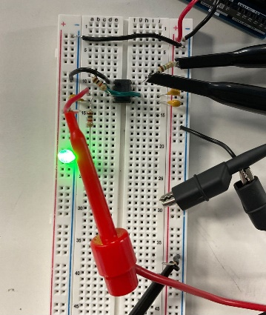

As seen above, two black probes are connected to the current sensor circuit. One is connected to the higher end of the resistor, and the other is connected to the lower end. The voltage can be measured if we take the difference between the high end and the low end.

If we expect a steady state current of 0.01 A, and we can reasonably measure a voltage of 20 mV, then the resistance might be: R = V/I = 20mV/10mA = 2 ohms.

1. **Show an example of the steady state current draw of your circuit while it is doing something**

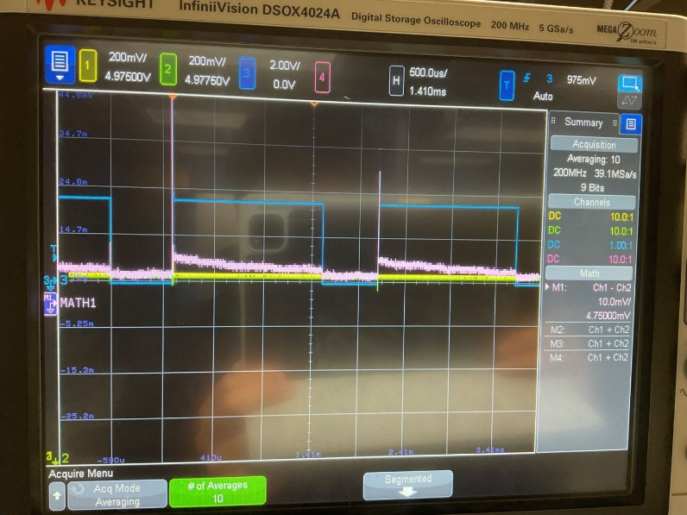

The above picture shows the steady state current draw of my 555-timer circuit while it is generating a square wave and LED lits.

There is around a 5mV drop across the current sensor resistor and a 1.5-ohm resistor is used. So, the steady current is 3mA.

1. **Show a measurement of the inrush current**

There is around a 400mV drop across the current sensor resistor and a 1.5-ohm resistor is used. So, the inrush current is 0.27A.

1. **Summarize the so what of what you observed**

Compared to the steady-state current, the inrush current is about 100 times the inrush current. And this number is reasonable since inrush current is the current draw in the circuit when the power is just plug-in. For the steady-state current we see above, the voltage of logic high is a bit higher than the logic low. And this is also reasonable since the circuit needs more current to pull the 555-timer circuit high.